**Part #2**

1. Download files from Blackboard
2. Open Word Document
3. Click on “Mailings” tab.
4. Click on “Start Mail Merge”
5. Click on Letter
6. Click on “Select Recipients”
7. Click on “Use Existing List”
8. Browse to the Excel file you download.
9. Highlight the text with Cursors and select “insert Merge Field” click on corresponding text

(Example – if the word you highlight is name then select name from the drop down list from “Insert Merge Field”

1. Repeat for all text fields.
2. Click “Finish &Merge” tab.
3. Select “Print Document”
4. Select Print All Record and hit Ok
5. Select “Microsoft XPS Document Writer” for Printer name and hit “OK”

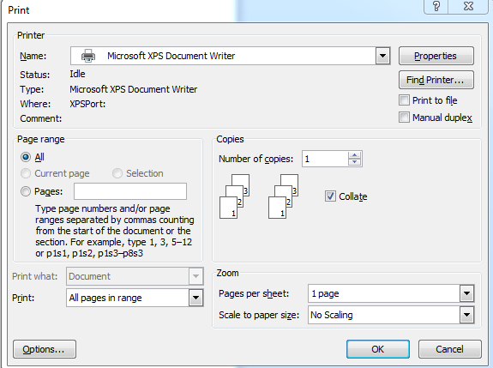

1. Save file to your desktop
2. Open your file. (You should see your results)

The General Manager of the local restaurant wants a new letter for their 4 customers.

Please create a letter for their customers using this field.

Name City Car Model Mileage Total Cost

George Oceanside Toyota Corolla 30 $9,000.00

Peggy Hemet Ford Fusion 12,000 $19,000.00

Punk San Diego Lexus ES300 60,000 $23,000.00

Emily Menifee Porsche 911 200,000 $29,001.00

Ernesto Santa Cruz BWM 750 145,000 $15,0000.00

1. Email me your Word doc and Excel file.